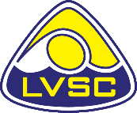 **HEAD COACH REPORT**

**AGM 2023**

It is hard to believe that it has been over a year since I started coaching with Lincoln Vulcans and seven months since my official start as Head Coach

During this time there has been a lot of change for the swimmers. The club has seen a complete restructure, which has since had its first review and things seem to be settling in nicely.

Swimmers have improved all round, with a significant increase in the number of swimmers that are now obtaining County qualifying times for the 400, 800 and 1500 swims, their hard work and commitment is really paying off.

There have been over four hundred County times achieved this season, not all have chosen to compete in all the swims, however this is an increase on last year, which is great for the swimmers and the club. It is still early days and there is a long way to go, but we are heading in the right direction.

I would like to take this opportunity to mention our Coaches/teachers, poolside helpers, parent liaison, Team Managers, Officials and Committee members for their support, over 76 people in total!

This club would not be able to run without you, THANK YOU

Pauline Gourley

Head Coach